Gila River Fire Department

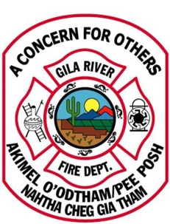
5002 N. Maricopa Road
P.O. Box 5083
Chandler, AZ 85226
Phone (520) 796-5900/Fax (520) 796-5919

PERMIT APPLICATION

This application is for tents and other permit events and activities as required by Title 22, Fire and Life Safety Code.

Date of Application: __________________________ Event Dates: ______________________

Business Name: _______________________________________________________________

Telephone Number: _______________________ Fax Number: _________________________

Project Address: ______________________________________________________________

Permit Purpose: (Attach Narrative Report or Explanation): __________________________________
____________________________________________________________________________
____________________________________________________________________________
Approximate Date/Time of set-up for Inspection: ____________________________________
___________________________________________________________________________________
___________________________________________________________________________________
Print Name of Applicant _______________________________________________________________
Signature of Applicant _________________________________________________________________

Plans Submitted with Application YES [ ] NO [ ] Number of Pages ________
(Plans submittal application MUST be filled out if yes is marked)

Site Plan Submitted with Application YES [ ] NO [ ] Number of Pages ________
(All special events and tent applications require a site plan with dimensions)

FOR OFFICE USE ONLY

PERMIT: APPROVED [ ] APPROVED WITH PROVISIONS [ ] DENIES [ ]

Effective Dates: ________________ Permit Number: ____________ Permit Expiration Date: _________
Special Previsions: _____________________________________________________________________
_____________________________________________________________________________________

F.P.B Authorized Signature: ______________________________ Date: _________________________

